EXPERIMENT 3

AIM
Benchmarking of 5G/6G Commumication for IoE Appliations based on Throughput, Latency, Reliability and Energy efficiency

Short work procedure
Import the Matplotlib library and define the number of IoE devices.
Set the assumed 5G network parameters, including capacity, latency, packet success rate, and energy consumption.
Calculate the offered traffic load and network utilization for each device count.
Calculate throughput, latency, reliability, and energy efficiency.
Display the calculated performance values for each device count.
Plot all four performance metrics in separate graphs using Matplotlib

Program code
import matplotlib.pyplot as plt

# Number of IoE devices
devices = [10, 50, 100, 200,267, 300,378, 400,467, 500,587,600]

# 5G network parameters (assumed)
capacity = 100 # Mbps
base_latency = 10 # ms
packet_success_rate = 0.98
energy_per_packet = 0.001 # Joules

# IoE device parameters
packet_size = 1200 # Bytes
packets_per_second = 20
simulation_time = 10 # Seconds

# Store results
throughput = []
latency = []
reliability = []
energy_efficiency = []

for n in devices:

# Total packets generated
total_packets = n * packets_per_second * simulation_time

# Offered traffic load (Mbps)
offered_load = (
n * packets_per_second * packet_size * 8 / 1e6
)

# Network utilization
utilization = offered_load / capacity

# 1. Throughput (Mbps)
t = min(
offered_load * packet_success_rate,
capacity
)

# 2. Latency (ms): increases with congestion
u = min(utilization, 0.95)
l = base_latency + 10 * u / (1 - u)

# 3. Reliability (%): decreases with congestion
r = 100 * packet_success_rate * max(
0, 1 - 0.2 * utilization
)

# 4. Energy efficiency (Mbit/J)
successful_packets = total_packets * r / 100

total_energy = (
total_packets
* energy_per_packet
* (1 + utilization)
)

e = (
successful_packets * packet_size * 8
/ total_energy / 1e6
)

# Store values
throughput.append(t)
latency.append(l)
reliability.append(r)
energy_efficiency.append(e)

# Display results
print(f"\nIoE Devices: {n}")
print(f"Offered Load : {offered_load:.2f} Mbps")
print(f"Throughput : {t:.2f} Mbps")
print(f"Latency : {l:.2f} ms")
print(f"Reliability : {r:.2f} %")
print(f"Energy Efficiency : {e:.2f} Mbit/J")

# Plot all four performance metrics
metrics = [
(throughput, "Throughput (Mbps)"),
(latency, "Latency (ms)"),
(reliability, "Reliability (%)"),
(energy_efficiency, "Energy Efficiency (Mbit/J)")
]

fig, axes = plt.subplots(2, 2, figsize=(11, 8))

for ax, (values, title) in zip(axes.flat, metrics):
ax.plot(devices, values, marker="o")
ax.set_title(title)
ax.set_xlabel("Number of IoE Devices")
ax.set_ylabel(title)
ax.grid(True)

plt.suptitle("5G Performance Benchmarking for IoE Applications")
plt.tight_layout()
plt.show()

Output

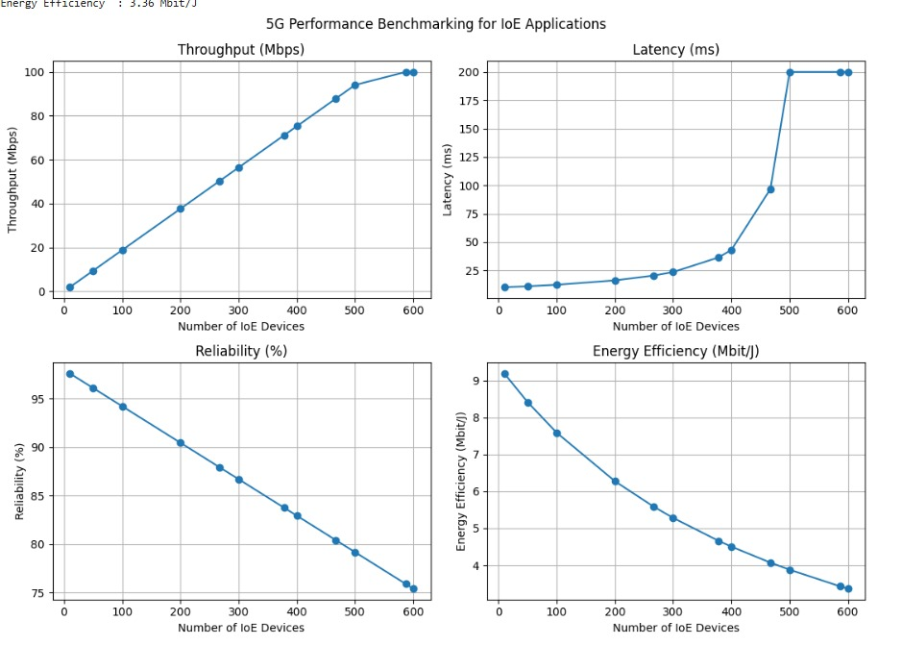

IoE device | Offered load | Throughput  (mbps) | Latency  (ms) | Reliability (%) | Energy efficient
267 | 51.26 | 50.24 | 20.52 | 87.95 | 5.58
378 | 72.88 | 71.12 | 36.46 | 83.78 | 4.66
467 | 89.66 | 87.87 | 96.75 | 80.43 | 4.07
587 | 112.70 | 10000 | 20000 | 75.91 | 3.43

Result
The 5G network performance for different numbers of IoE devices was simulated successfully. The graphs show how increasing device numbers affect throughput, latency, reliability, and energy efficiency. As the number of devices increases, network congestion and latency increase, while reliability and energy efficiency generally decrease. Throughput increases with traffic load until the network capacity limit is reached.

Program code 1
import matplotlib.pyplot as plt
# Number of IoE devices
devices = [10, 50, 100, 200, 300, 400, 500]
# 5G network parameters (assumed)
capacity = 100 # Mbps
base_latency = 10 # ms
packet_success_rate = 0.98
energy_per_packet = 0.001 # Joules
# IoE device parameters
packet_size = 1200 # Bytes
packets_per_second = 20
simulation_time = 10 # Seconds
# Store results
throughput = []
latency = []
reliability = []
energy_efficiency = []
for n in devices:
# Total packets generated
total_packets = n * packets_per_second * simulation_time
# Offered traffic load (Mbps)
offered_load = (
n * packets_per_second * packet_size * 8 / 1e6
)
# Network utilization
utilization = offered_load / capacity
# 1. Throughput (Mbps)
t = min(
offered_load * packet_success_rate,
capacity
)
# 2. Latency (ms): increases with congestion
u = min(utilization, 0.95)
l = base_latency + 10 * u / (1 - u)
# 3. Reliability (%): decreases with congestion
r = 100 * packet_success_rate * max(
0, 1 - 0.2 * utilization
)
# 4. Energy efficiency (Mbit/J)
successful_packets = total_packets * r / 100
total_energy = (
total_packets
* energy_per_packet
* (1 + utilization)
)
e = (
successful_packets * packet_size * 8
/ total_energy / 1e6
)
# Store values
throughput.append(t)
latency.append(l)
reliability.append(r)
energy_efficiency.append(e)
# Display results
print(f"\nIoE Devices: {n}")
print(f"Offered Load : {offered_load:.2f} Mbps")
print(f"Throughput : {t:.2f} Mbps")
print(f"Latency : {l:.2f} ms")
print(f"Reliability : {r:.2f} %")
print(f"Energy Efficiency : {e:.2f} Mbit/J")
# Plot all four performance metrics
metrics = [
(throughput, "Throughput (Mbps)"),
(latency, "Latency (ms)"),
(reliability, "Reliability (%)"),
(energy_efficiency, "Energy Efficiency (Mbit/J)")
]
fig, axes = plt.subplots(2, 2, figsize=(11, 8))
for ax, (values, title) in zip(axes.flat, metrics):
ax.plot(devices, values, marker="o")
ax.set_title(title)
ax.set_xlabel("Number of IoE Devices")
ax.set_ylabel(title)
ax.grid(True)
plt.suptitle("5G Performance Benchmarking for IoE Applications")
plt.tight_layout()
plt.show()

